Pet Boarding Management System Documentation

Organization Name
Green Valley Pet Boarding
System Overview

The Pet Boarding Management System is a Python-based application designed to help Green Valley Pet Boarding manage pet, owner, and reservation information efficiently. The system provides a graphical user interface (GUI) that allows staff to easily enter, update, and view boarding data in one centralized location.

This system replaces manual tracking methods, reducing the likelihood of errors such as missing information or scheduling confusion. It allows staff to quickly access important details about pets, their owners, and their boarding schedules.
Problem Addressed

Prior to this system, pet boarding information was managed manually, which made it difficult to track reservations and access important details. This often led to confusion, inefficiencies, and the potential for scheduling errors.

The implemented system solves these issues by organizing all data into a structured, easy-to-use interface that improves accuracy and accessibility.
System Features and Functionality
The application includes the following features:
- Add and store owner information, including name, phone number, and email
- Add and store pet information, including name, type, age, medications, and notes
- Associate pets with their respective owners
- Create boarding reservations with check-in and check-out dates
- View reservations filtered by owner
- Track reservation status (not checked in, checked in, checked out)
- Perform check-in and check-out operations
- Delete reservations when necessary
- Use a calendar widget to easily select reservation dates

System Design and Structure
- Owner Class
Stores owner details and maintains a list of pets associated with each owner.
- Pet Class
Stores pet-specific information and links each pet to its owner.
- Reservation Class
Stores reservation details, including check-in/check-out dates and status tracking.

Data Management
The system uses collections to manage data efficiently:
- Lists are used to store owners, pets, and reservations
- A dictionary is used to map reservation display labels to their corresponding records
These structures allow for dynamic updates and easy retrieval of information within the application.

User Interface
The graphical user interface is built using Tkinter and includes:
- Input fields for entering owner and pet information
- Dropdown menus for selecting existing owners, pets, and reservations
- Buttons for adding records and managing reservation status
- A scrollable layout to ensure all controls remain accessible
- Calendar pop-ups for selecting dates
The interface is designed to be user-friendly and intuitive for staff members.

Program Execution and Results
The system runs without syntax or runtime errors and successfully performs all intended operations. Users can:
- Add new owners and pets
- Create and manage reservations
- Track check-in and check-out status
- View updated reservation lists dynamically

Sample output from the system (console logs):
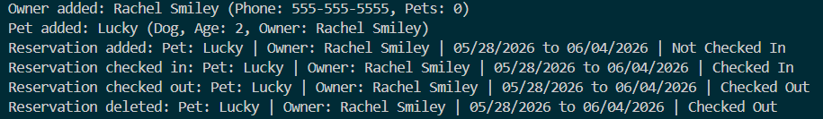

Conclusion
The Pet Boarding Management System successfully meets the requirements of the project by providing a functional, user-friendly application that manages pet boarding data efficiently. The use of object-oriented design, collections, and a graphical interface ensures that the system is organized, reliable, and easy to use.

